# Overview

This overview describes the features of JDElite diagram editor. The free accessible demo version has all of the built-in features except the access to the file system. There are three sample diagrams embedded in it. They can be opened and edited but the modifications cannot be saved (in the full version the diagrams are saved in JSON format). The flow direction of diagrams can be either top to bottom or left to right and can be switched at any time during the design process. You can build a diagram by simply drag-and-drop nodes from the palette and by entering connection links between them using the mouse over the pop-up handles:



Nodes are assigned names at creation time that have to be unique across the diagram. The names are either automatically generated or you can choose to enter the node name when you drop the node. Duplicate names are rejected. You can edit the nodes background/foreground colors either for groups of nodes from the global *Settings* dialog, or individually for any particular node from its *Properties* dialog:



From the node’s *Properties* dialog, you can show/hide or edit node names, show/hide or select a node icon, edit the background/foreground colors and enter text inside, above and/or below the node. This dialog can be invoked from the right-click context menu or double clicking on the node:



The nodes are positioned on a rectangular grid that consists of layers across the flow direction and lanes along the flow direction, and are located in the cells at the intersections. The areas between the layers are called *layer pipes*, and the areas between the lanes are called *lane pipes*. The connection links are traced along these pipes. The nodes can be moved to different grid cells, as well as copied and pasted. The links can also be moved to different nodes to reconnect them using the mouse dragging the connection ports:



You can use on your choice the side swim lanes – left/top and right/bottom. You can choose to enable the association links to show a different kind of relations between some nodes. You can also select different colors for the node icons by nodes types. From the right-click context menu outside of nodes and links you can add or remove layers and/or lanes:



You can attach labels to the connection ports of the nodes in the node’s *Properties* dialog under the *Connectivity* tab. You can also attach labels to the links in the link’s *Properties* dialog. In this dialog you can change a different color for the link:



The size of the nodes can be changed either by groups from the *Settings* dialog, tab *Node Size*, or individually by dragging the node outline with the mouse. Some link segments can be repositioned either by dragging the whole segment or by dragging its corner point. The accepting areas are highlighted during dragging. For diagrams that are larger than the browser window there is a convenient thumbnail view dialog invokable from a button in the top right block of the editor. You can also change the flow direction by double clicking the arrow button in that block, as well as you can select a different scale of the diagram:



Container blocks with two levels of nesting allow the user to create functional groups of nodes. After the initial drop, as well as at any time later, a block can be expanded or collapsed by clicking on the expand/collapse icon. The block can be sized to the desired dimension by extending or shrinking it in any direction using the resize menu that pops up at the upper left corner of the outline in expanded state. If there is not enough free space around the block to expand or extend it, additional layers and/or lanes are to be inserted.



Following is a brief cheat list of the wide range of features, accessible from the toolbar, from the context menus, or by using the mouse pointer.

* Most of the actions on the toolbar are available from the drop-down menu in the upper left corner.
* A new node is created either by dragging an item from the palette on the right to an accepting cell on the canvas, or by selecting a node type from the context menu from an empty cell. The list shows only nodes that are accepted at this location:

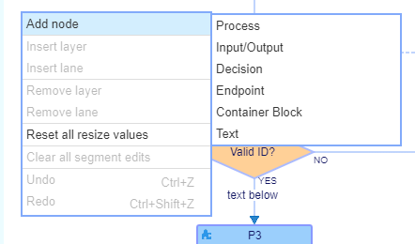

* The diagram frame size can be modified at any time by inserting new layers or lanes, and/or removing the empty ones.

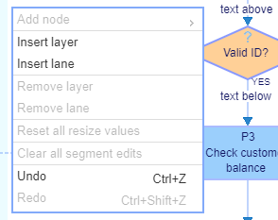

* Container blocks with two levels of nesting allow the user to create functional groups of nodes. After the initial drop, as well as at any time later, a block can be expanded or collapsed by clicking on the expand/collapse icon. The block can be sized to the desired dimension by extending or shrinking it in any direction using the resize menu that pops up at the upper left corner of the outline in expanded state. If there is not enough free space around the block to expand or extend it, additional layers and/or lanes are to be inserted.
* The decision node has two outputs: ‘YES’ and ‘NO’, and accepts multiple inputs. The configuration of the outputs of the decision nodes can be edited from the Edit Decision Layout dialog, which is accessed from the context menu on the decision node.
* As mentioned above, the connections between the nodes are created by dragging the mouse between the connection handles that are popping up on the outlines of the accepting nodes under the mouse pointer. The connection is routed after the mouse pointer is dropped over an accepting handle and the handle is highlighted. Later on, a connection can be reassigned by dragging any of the ends of the link to an accepting handle on a different node. The tooltips under the mouse pointer suggest the appropriate action in a particular context.
* There are special start and end layers, as well as left and right swim lanes. They all accept their specific node types from the palette or from the mouse context menus.
* In addition to the standard link connections, there is an additional category of association links. They can be traced sidewise between the nodes, and are represented by dashed lines.
* The data flow direction can be initially selected to be either top to bottom or left to right, and can be changed or switched back and forth at any time by double-clicking the on-screen ‘Data Flow’ button above the palette, or from the Settings dialog shown above. The diagram is rotated and flipped without otherwise affecting its content. Rather than using a simple rotation, the flipping preserves the correlation between the diagram internal directions and the canvas coordinate system axes.
* The nodes and the links can be selected by the mouse. Multiple selections are carried out by either pressing Ctrl + click or by pressing Shift + drag. Selections can be removed using the toolbar, the context menu, or the keyboard.
* Nodes can be moved at any time during the design process by simply dragging them with the mouse to new locations. The dragged node can be dropped over an empty cell, or over a layer pipe or lane pipe. In the latter case a new layer and/or a new lane are first created, then the node is positioned in the new cell under the mouse pointer. The connected links are re-routed automatically.
* From the node *Properties* dialog, a reasonably sized text content can be added inside the node, as well as above or below it.
* All described editor actions are undoable with unlimited number of undo/redo steps (except node resizing and node color selections).
* The editor has a proprietary file system browser that is invokable when a server connection is available. It has full access to the file system. The created diagrams can be saved in existing folders or new folders can be created. Files and folders can be renamed or removed as well. The default server connection uses *node.js*.